**CSCI-SHU 210 Data Structures**

**Recitation 4 Array Based Sequences and Dynamic Array**

You have a series of tasks in front of you. Complete them! Everyone should code on their own computer, but you are encouraged to talk to others, and seek help from each other and from the Professor/TA/LA.

**Important:**

* **Understand what is a “low-level array”**
  + Also called “static array”, “compact array”
  + Fixed capacity, continuous chuck of memory, each cell stores the same type.
  + Supports indexing in O(1) time.
* **Understand what is a “dynamic array”**
  + Supports append( ), pop( ) in O(1) amortized time.
  + Capacity can grow and shrink.
* **Understand what is a “python list”**
  + Each cell can store different type. How?

**Question 1 (Implement a Dynamic Array)**

Again, what is a Dynamic Array?

Answer: Dynamic array is an array based data structure, that can **shrink/grow its capacity automatically** when it is too full or too empty.

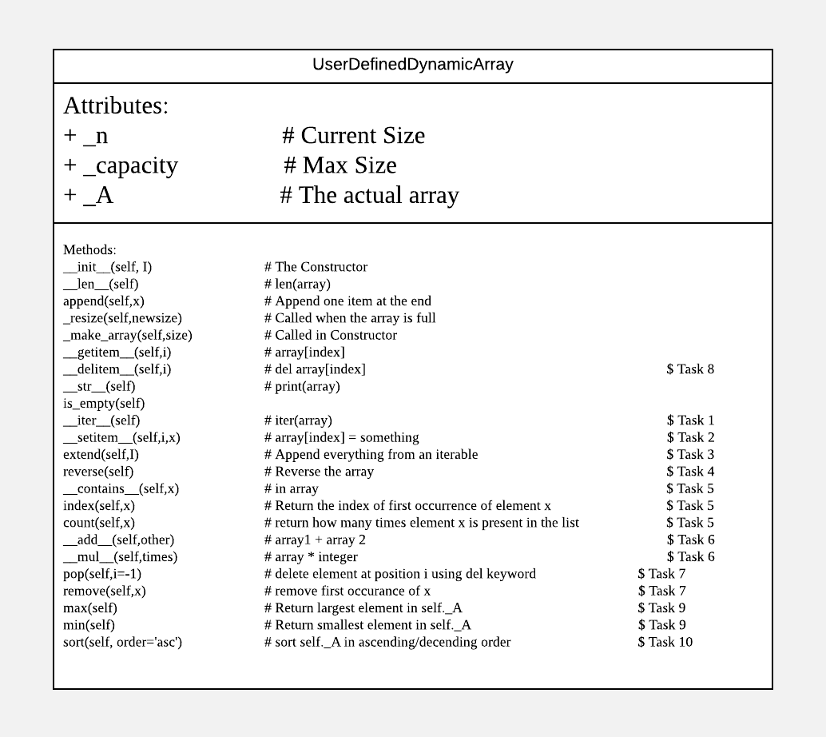

Figure 1: The UserDefinedDynamicArray Class UML Diagram.

Your task: Implement UserDefinedDynamicArray, so it behaves like our list class. Refer to DynamicArray.py for details.

**Detailed Tasks breakdown:**

Task # 1: Print the lists. To print lists, we have to:

Implement __iter__ function.

* print function calls __str__ function, and __str__ function calls __iter__ function to get all elements.
* __iter__ function returns an iterable object by ‘yield’ keyword.
* FYI, __iter__ is called by “for xxx in list” code.

>>> l = [1,2,3,4]

>>> b = l.__iter__()

>>> b

<list_iterator object at 0x10ade4208>

Task # 2: Delete elements from the list.

Implement __setitem__ function.

* FYI, __delitem__(self, i) supports ‘del’ keyword.
* FYI, __setitem__(self, i, x)supports ‘list[index] = value’ operation.
* Question: Why does __delitem__ need __setitem__ ?
  + We need to shift elements if the element was deleted in the middle.

>>> l = [1,2,3,4]

>>> del l[0:2]

>>> l

[3, 4]

>>> l[1] = 99

>>> l

[3, 99]

Task # 3: Extend another iterable.

Implement extend(self,I) method.

* Add everything from I parameter into self._A

>>> l = [1,2,3,4]

>>> l2 = [4,5,6]

>>> l.extend(l2)

>>> l

[1, 2, 3, 4, 4, 5, 6]

Task # 4: Reverse a list.

Implement reverse(self) method.

* Reverse self._A.

>>> l = [1,2,3,4]

>>> l.reverse()

>>> l

[4, 3, 2, 1]

Task # 5: Code three functions.

Implement __contains__(self, x); index(self, x); count(self, x) methods.

* __contains__(self, x) will check whether element x is present in the list. If yes return True, otherwise False. #### __contains__ supports ‘in’ operator
* index(self, x) will return the index of element x in the list. If x is present multiple times, it will return the first index of x, otherwise it will return None
* count(self, x) will return how many times element x is present in the list. If the element x is not present, it will return 0.

>>> l = [1,2,3,4,1]

>>> 1 in l

True

>>> l.index(1)

0

>>> l.count(1)

2

Task # 6: Supporting Array + Array; Array * Integer operations

Implement __add__(self,other) and __mul__(self,times) methods.

* __add__ will implement '+' Operator Overloading for UserDefinedDyamicArray Class. myArray1+myArray2 will return a UserDefinedDyamicArray containing all the elements of myArray1 and then myArray2
* __mul__ will implement '*' Operator Overloading for UserDefinedDyamicArray Class. myArray1*3 will return a UserDefinedDyamicArray having myArray1 elements three times.

>>> l1 = [1,2,3,4]

>>> l2 = [4,5,6]

>>> l1 + l2

[1, 2, 3, 4, 4, 5, 6]

>>> l1 * 3

[1, 2, 3, 4, 1, 2, 3, 4, 1, 2, 3, 4]

Task # 7: pop(i) and remove(value)

Implement pop(i) and remove(value) methods.

* By default, pop(i) will return the last element from the list and delete that element from the list using del keyword.
* if i value is specified then we will delete the element at position i and return it to the calling method.
* remove() function takes a ‘value’, and performs element searching to remove this value.
* __delitem__() takes an ‘index’ instead.
* remove(x) will delete the element x from the list. If x is present multiple times, it will delete the first occurrence of x.

>>> l1 = [1,2,3,4,1]

>>> l1.pop(2) # Pop index 2

3

>>> l1.remove(1) # Remove first occurrence of value 1

>>> print(l1)

[2, 4, 1]

Task # 8: Modify __delitem__ function so it can shrink the array capacity.

* Current __delitem__(self, i) function does not shrink the array capacity.
* We want to shrink the array capacity by half if total number of actual elements reduces to one fourth of the capacity.

>>> l1 = [20,40,60,80,100,120,140,160,180,200]

>>> print(l1, “capacity:”, l1._capacity)

[20,40,60,80,100,120,140,160,180,200] capacity: 16

>>> for i in range(7):

>>> del l1[0]

>>> print(l1, “capacity:”, l1._capacity)

[160,180,200] capacity: 8

Task # 9: Returning Max/Min elements of the array.

* max(self) function which return maximum element among the elements of self._A.
* min(self) function which return minimum element among the elements of self._A.

>>> l1 = [4,7,3,1,9]

>>> l1.max()

9

>>> l1.min()

1

Task # 10: Sorting UserDefinedDynamicArray.

Implement sort(self, order = ‘asc’) method.

* sort function which will sort the list by default ascending order
* otherwise descending order if order = 'desc'

>>> l1 = [4,7,3,1,9]

>>> l1.sort()

>>> l1

[1, 3, 4, 7, 9]

>>> l1.sort(order = ‘desc’)

>>> l1

[9, 7, 4, 3, 1]